

Lab Report

LAB – 07 CSE - 206

Presented By:

* Name: Tunazzinur Rahman Kabbo
* Intake: 44
* Sec: 07
* ID: 19202103268

CSE - 206

Presented To:

* Iffat Tamanna

Lecturer, BUBT

Department of Computer Science & Engineering

Email: [iffat@bubt.edu.bd](mailto:iffat@bubt.edu.bd)

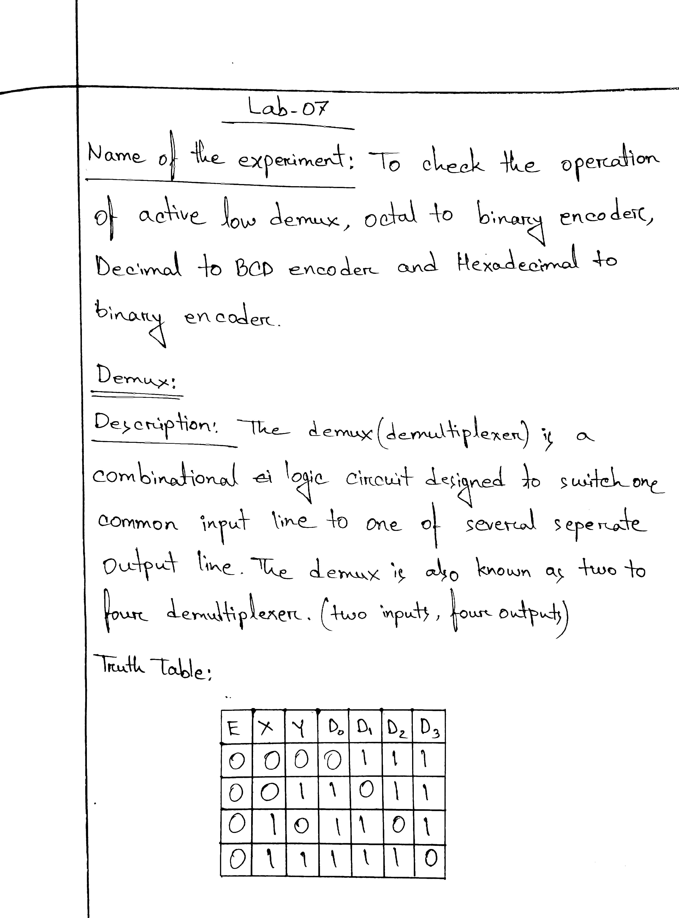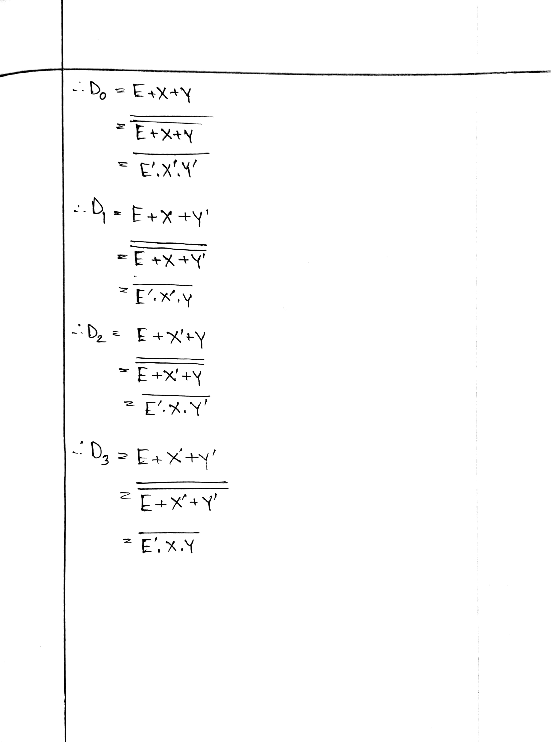

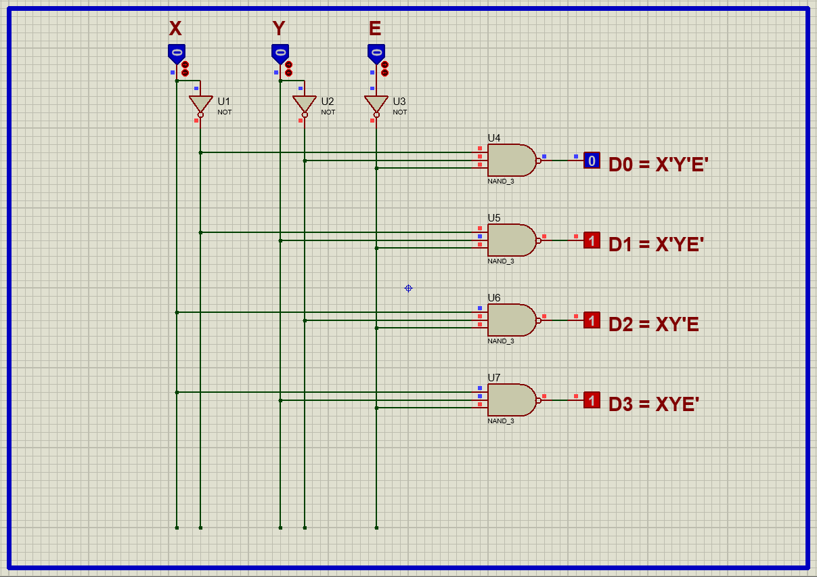

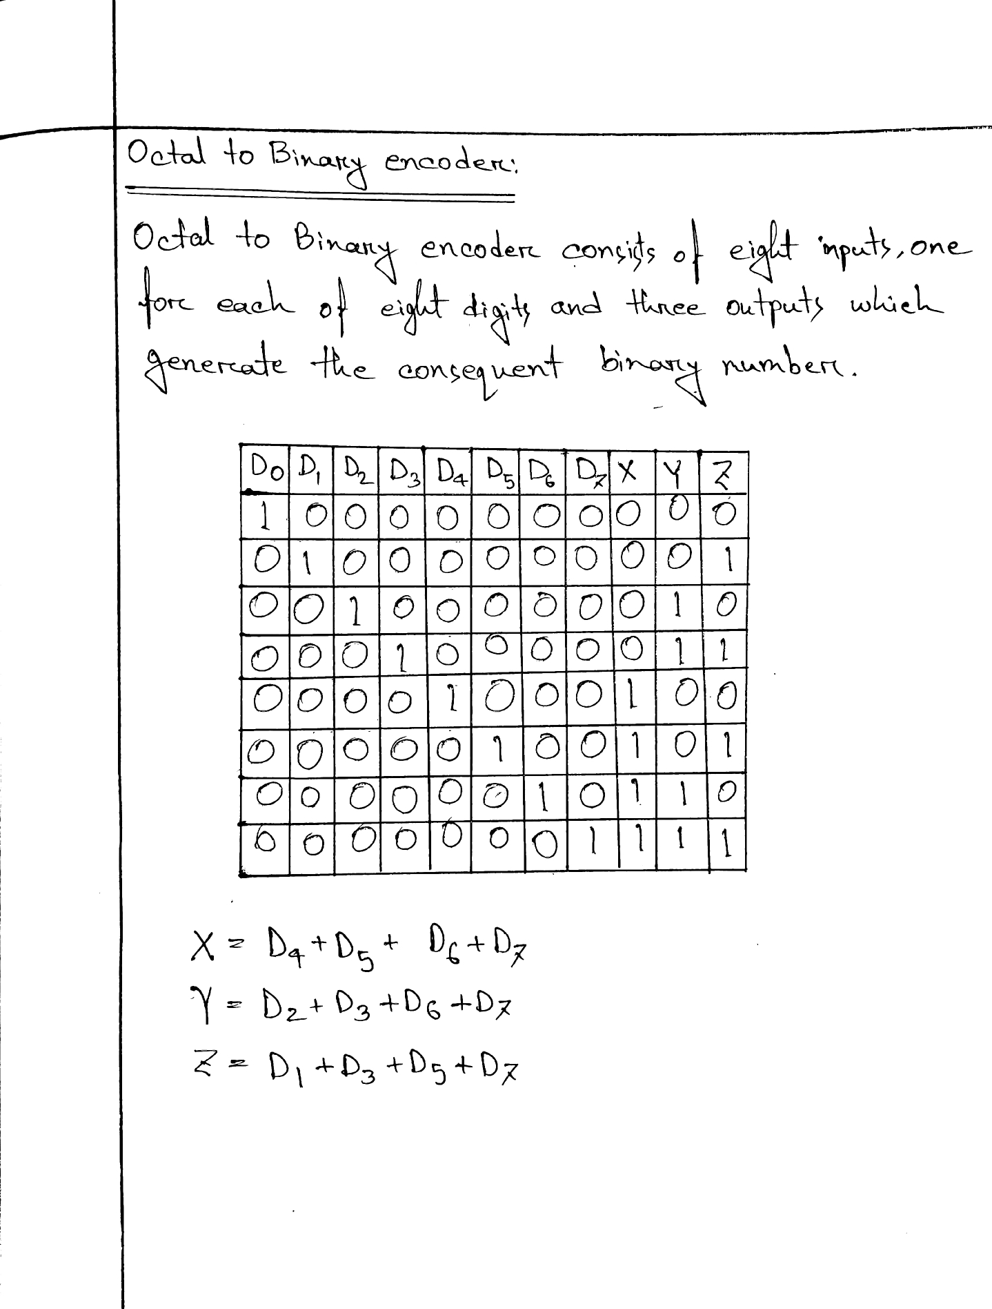

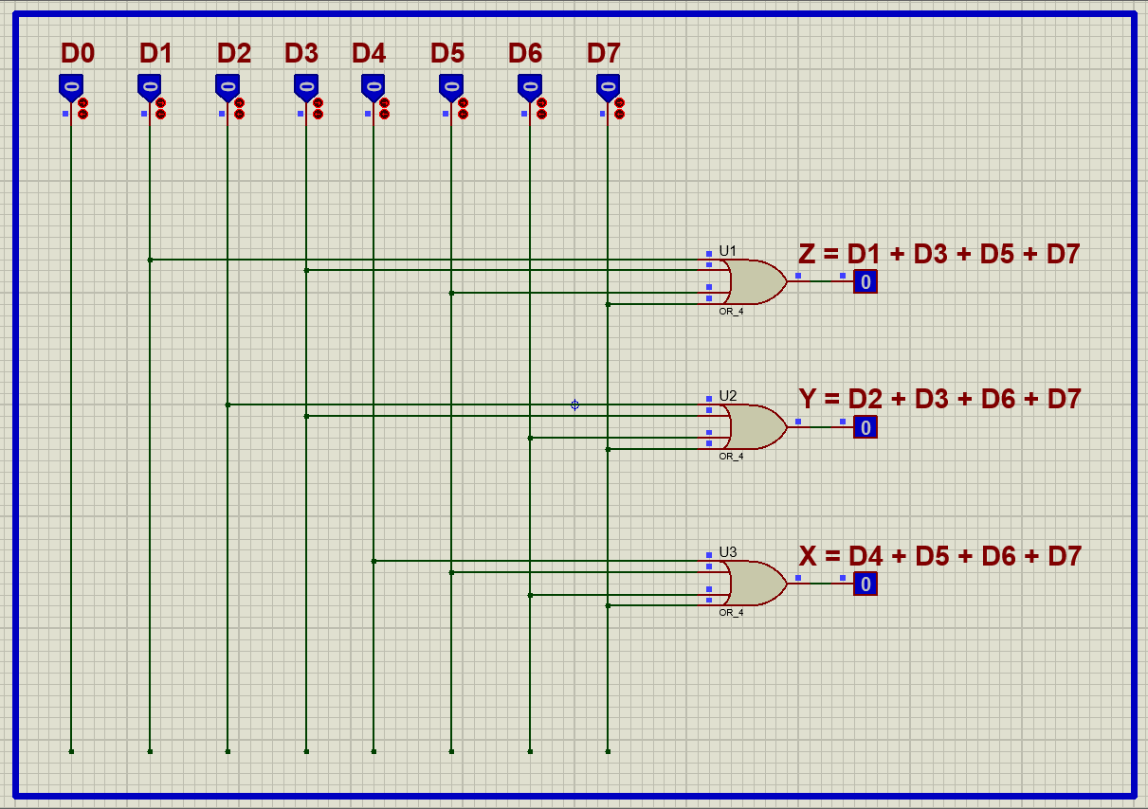

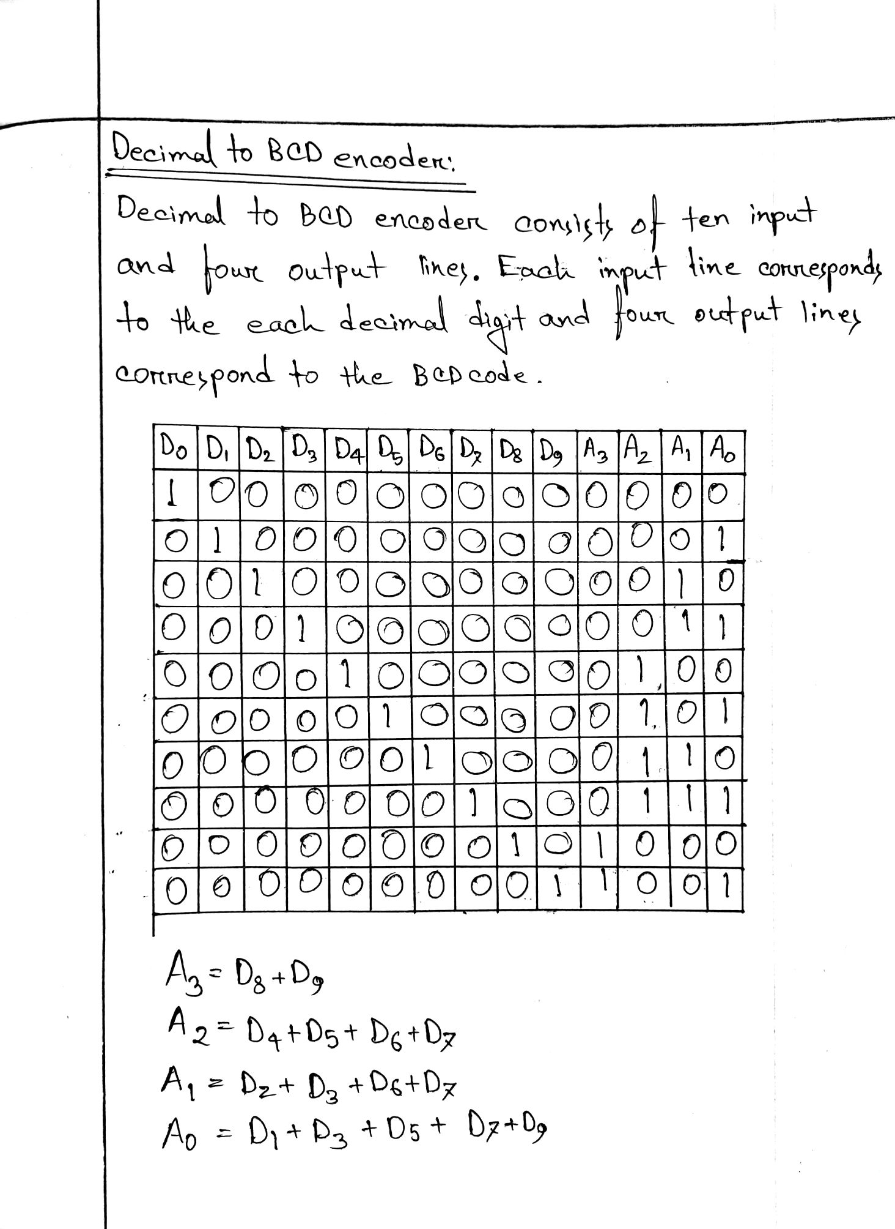

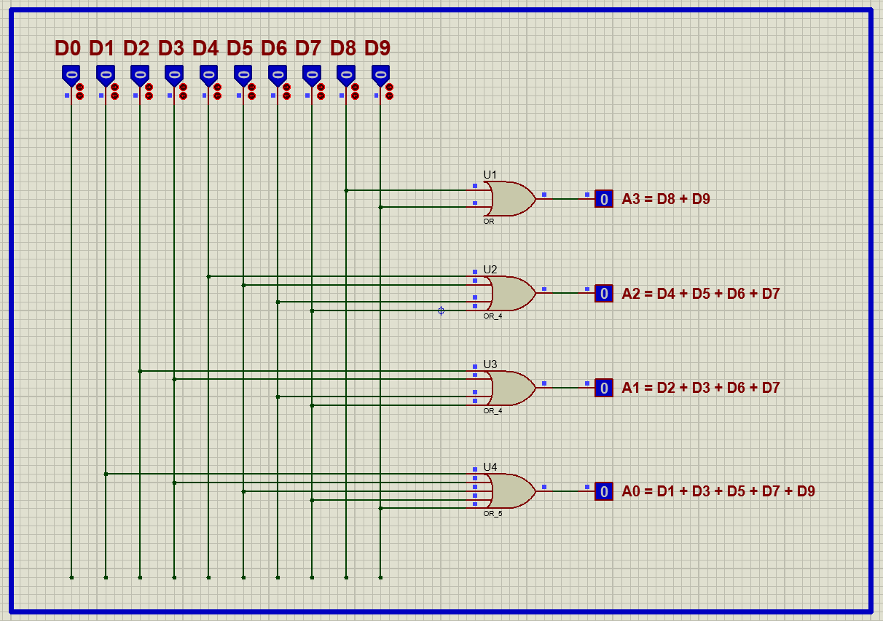

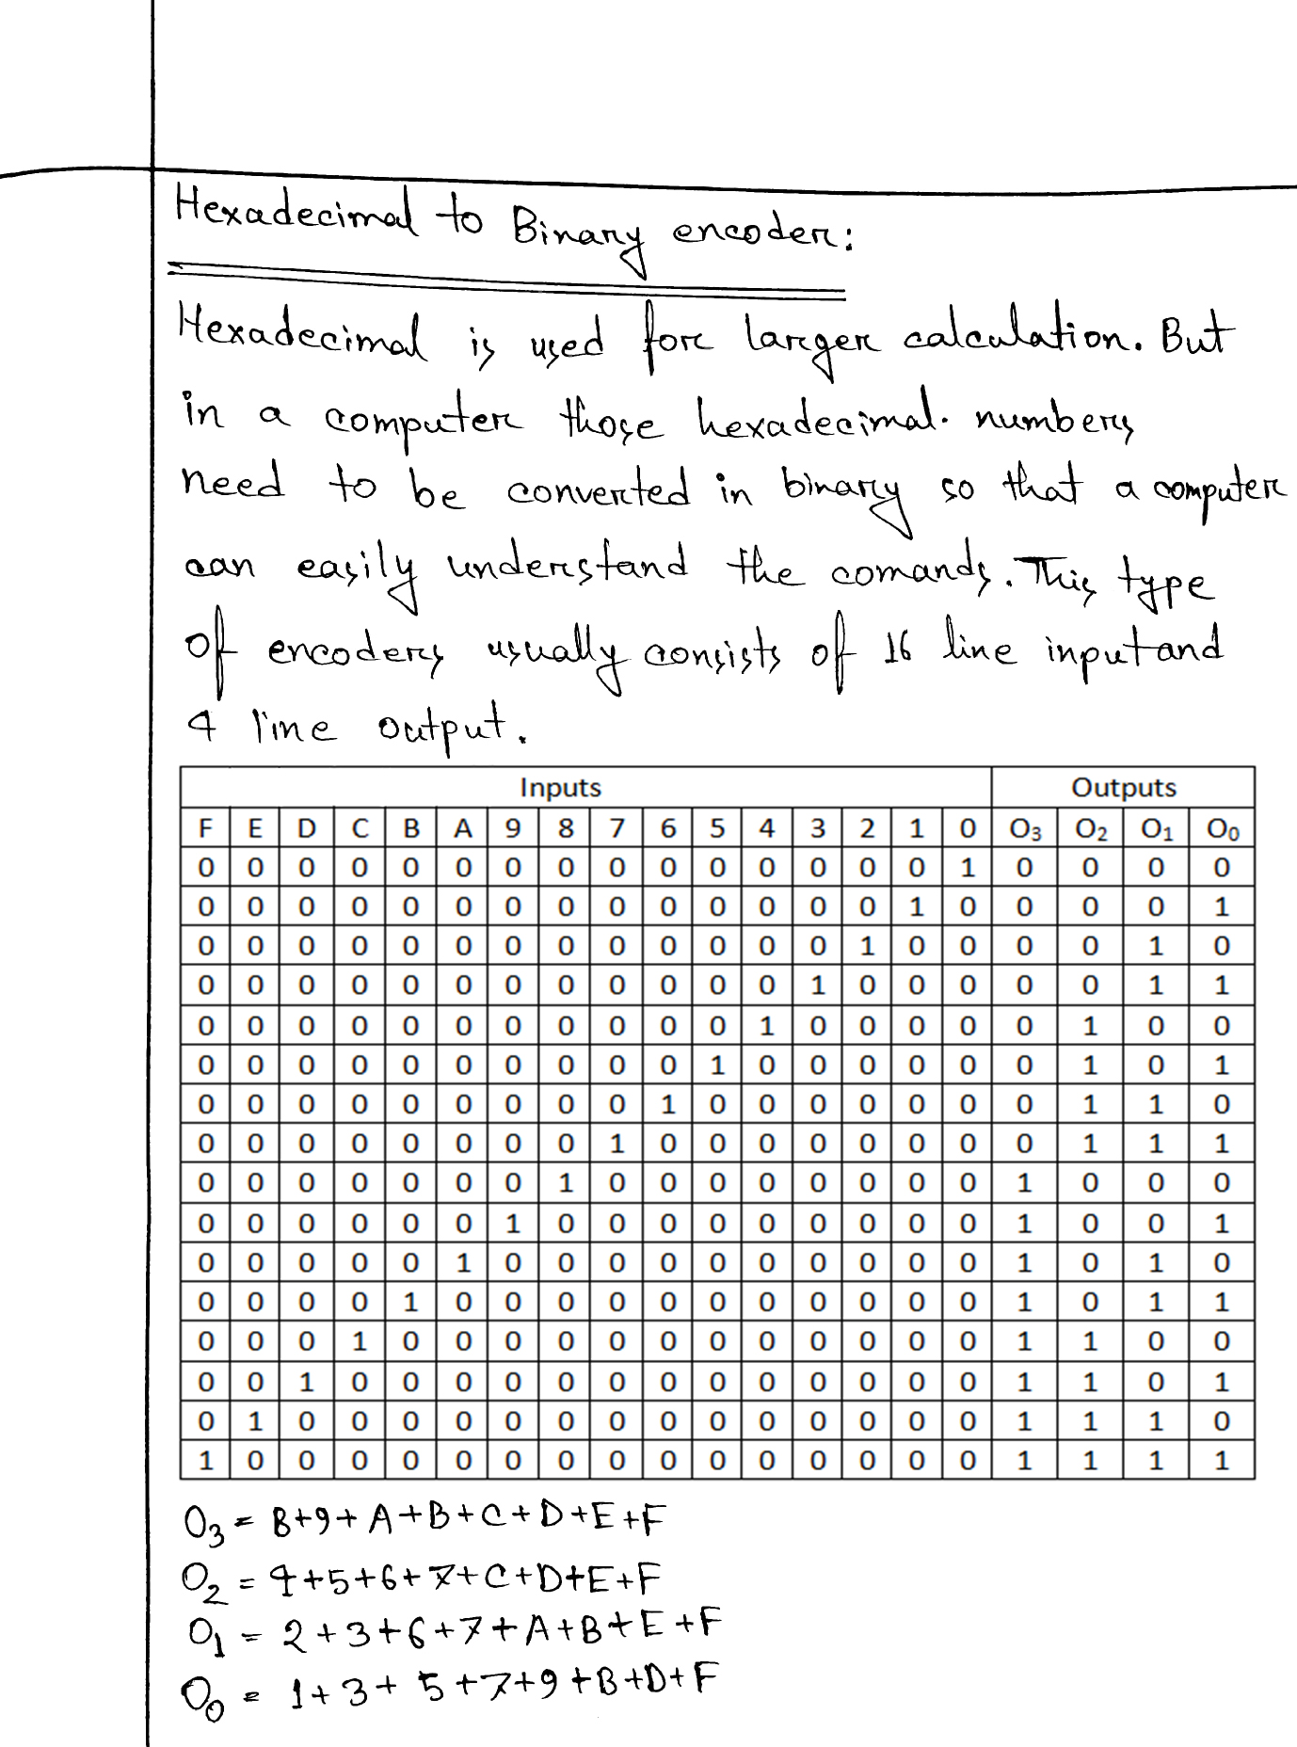

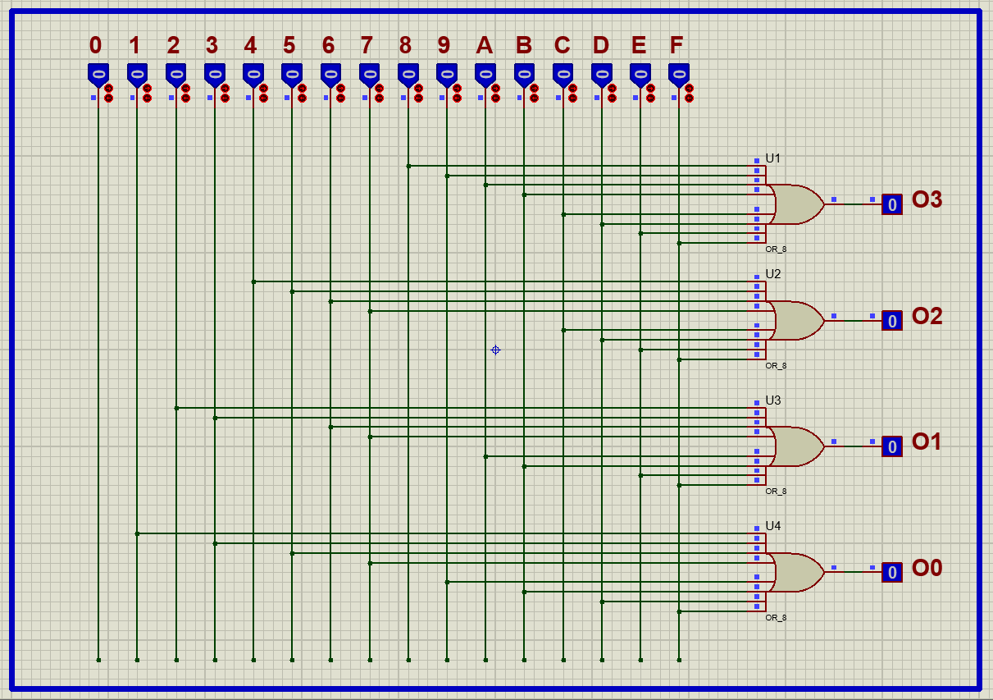

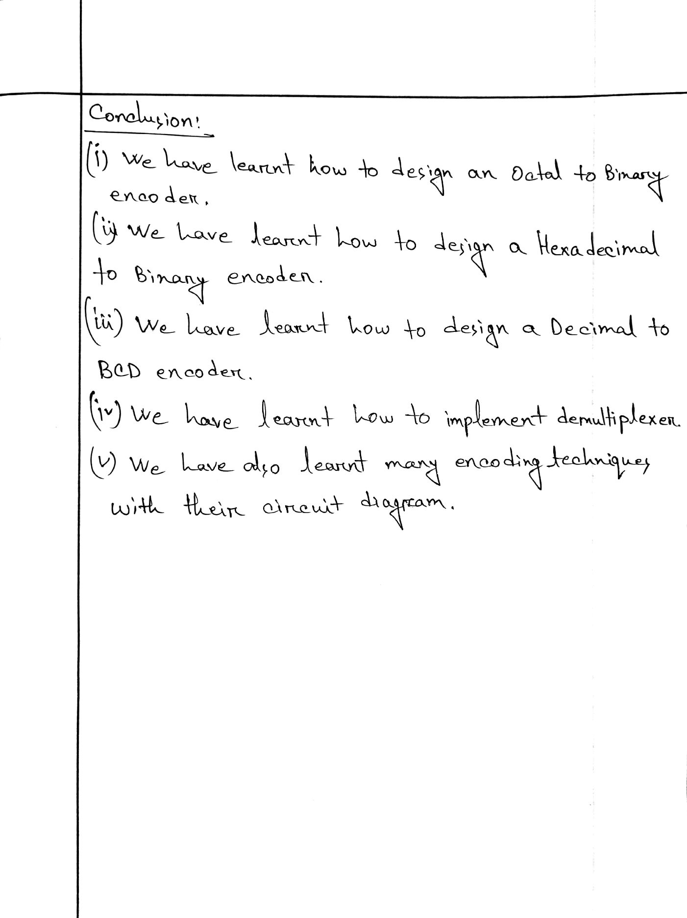

CSE – 206

THE END

CSE – 206